As the shading level increased from 3 to 5, the error variation also increases. Here are some intuitions of how do CW model and NC model handle model order reduction. And the possible future work will also be listed.

1. **Both Error Average and Error Variation Increase**

CW Model (3 levels -> 5 levels)

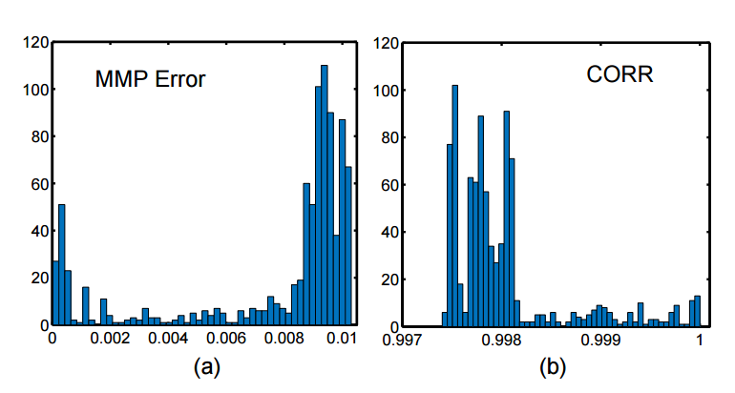(3 levels, ave: 0.39%/0.999)

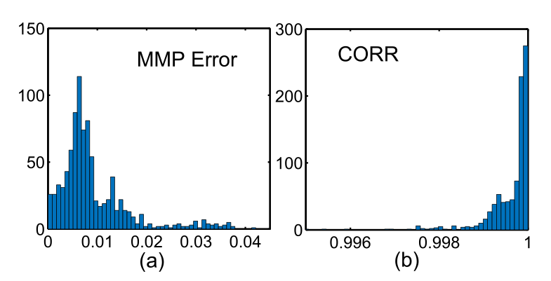(5 levels, ave: 0.92%/0.999)

NC Model (3 levels -> 5 levels)

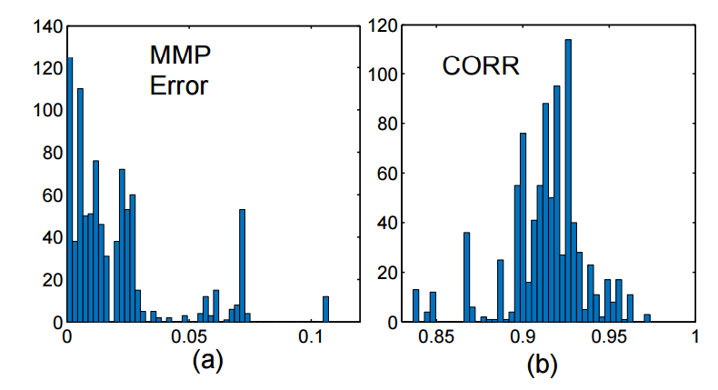 (3 levels: ave:2.03%/0.93)

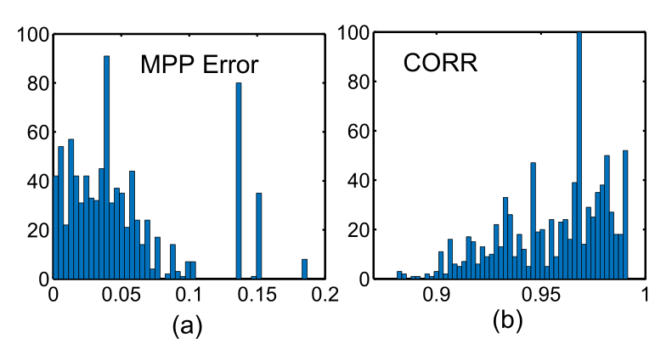(5 levels, ave: 5.15%,/0.96)

1. **Runtime**

3 levels:

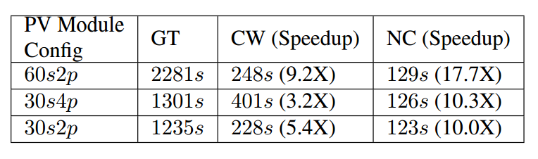

5 levels:

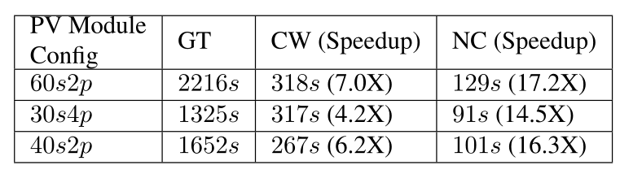

The runtime of CW NC models of 30s4p&40s2p decreases because the model order reduces. Right now, these 2 modules have 2 bypass diodes for each chain. Therefore, the colony number of each PV module decrease, and model order of the corresponding CW/NC model decreases as well.

The runtime of GT model remains the same. This infers that HSpice will not optimize runtime if it seems 2 or more identical solar cells.

1. **Accuracy of model order**

***The accuracy decreases from 3 levels to 5 levels because the GT model’s information increases a lot, while CW/NC model’s information remains nearly the same.***

Let us assume the PV module is 30s4p with 2 bypass diodes. The number of elements (dominated by number of diodes, because it is non-linear and takes computational time) of each models are:

GT: 30*4+2*4 = 128

CW: (1+2)*2*4 = 24

NC: (1+2)*2 = 6

This complexity ratio among these 3 models are roughly corresponded to the runtime.

$$\frac{GT}{CW} ≈6,\frac{GT}{NC}≈15$$

We can compare the models to polynomials. GT has 128 terms, we try to use 24 terms (CW) and 6 terms (NC) to approximate the GT. And somehow, our CW and NC models seem to take the lower orders of the GT. Therefore, it cannot guarantee converging every time.

For example, the following figure shows the best I can do to fit CW and NC model:

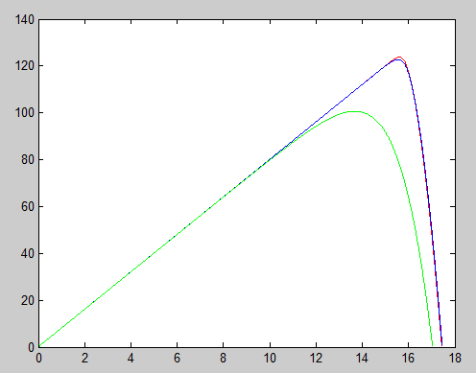

Red: GT

Blue: CW

Green: NC

The sharp transition of the curve is like the high-order terms. CW can still fit that. However, at the very transition, it has error. On the other hand, NC model cannot approximate the transition because it doesn’t have that much of information, no matter how hard I try to curve fitted the model.

Most of the times, the coefficients of high-order terms of the GT model are small. Therefore, CW and NC model can do well. However, if 5% of cases lower-order model cannot approximate high-order model, the lower-order model still can not be used.

1. **The next step**
   1. Reduce the number of sampling point? However, it is not reducing the model’s complexity
   2. Behavioral model to treat each colony as a black box